**Lab Assignment 7:**

**Question 1: Sentimental analysis using twitter streaming (related to your project)**

**Description**:

Here we could successfully accept the twitter stream to our spark system and perform the sentiment analysis on it using the Stanford core NLP. Here we shall take the twitter streams, convert the rdd’s to string and send it to the Stanford core NLP for sentiment analysis.

**Screenshots:**

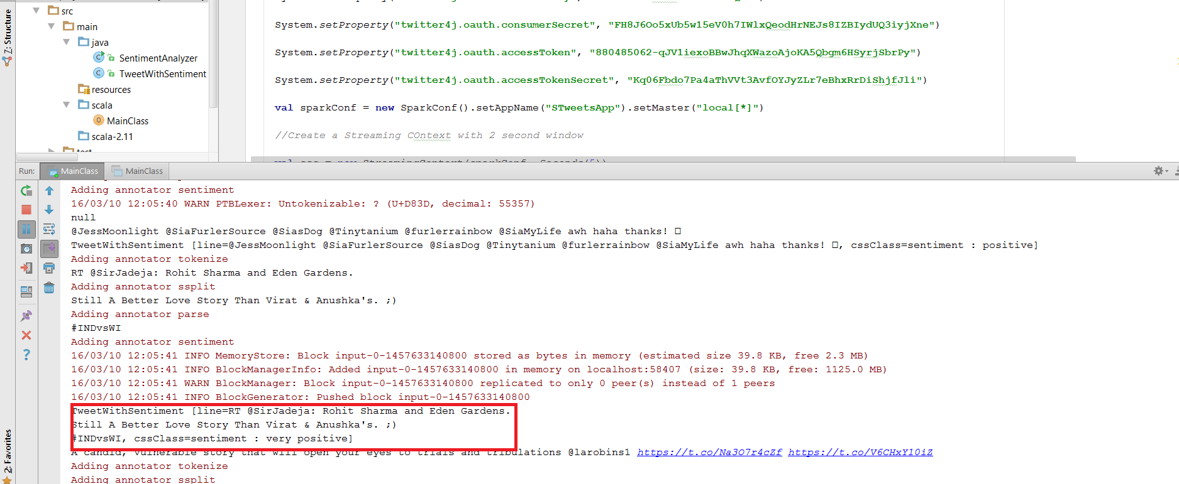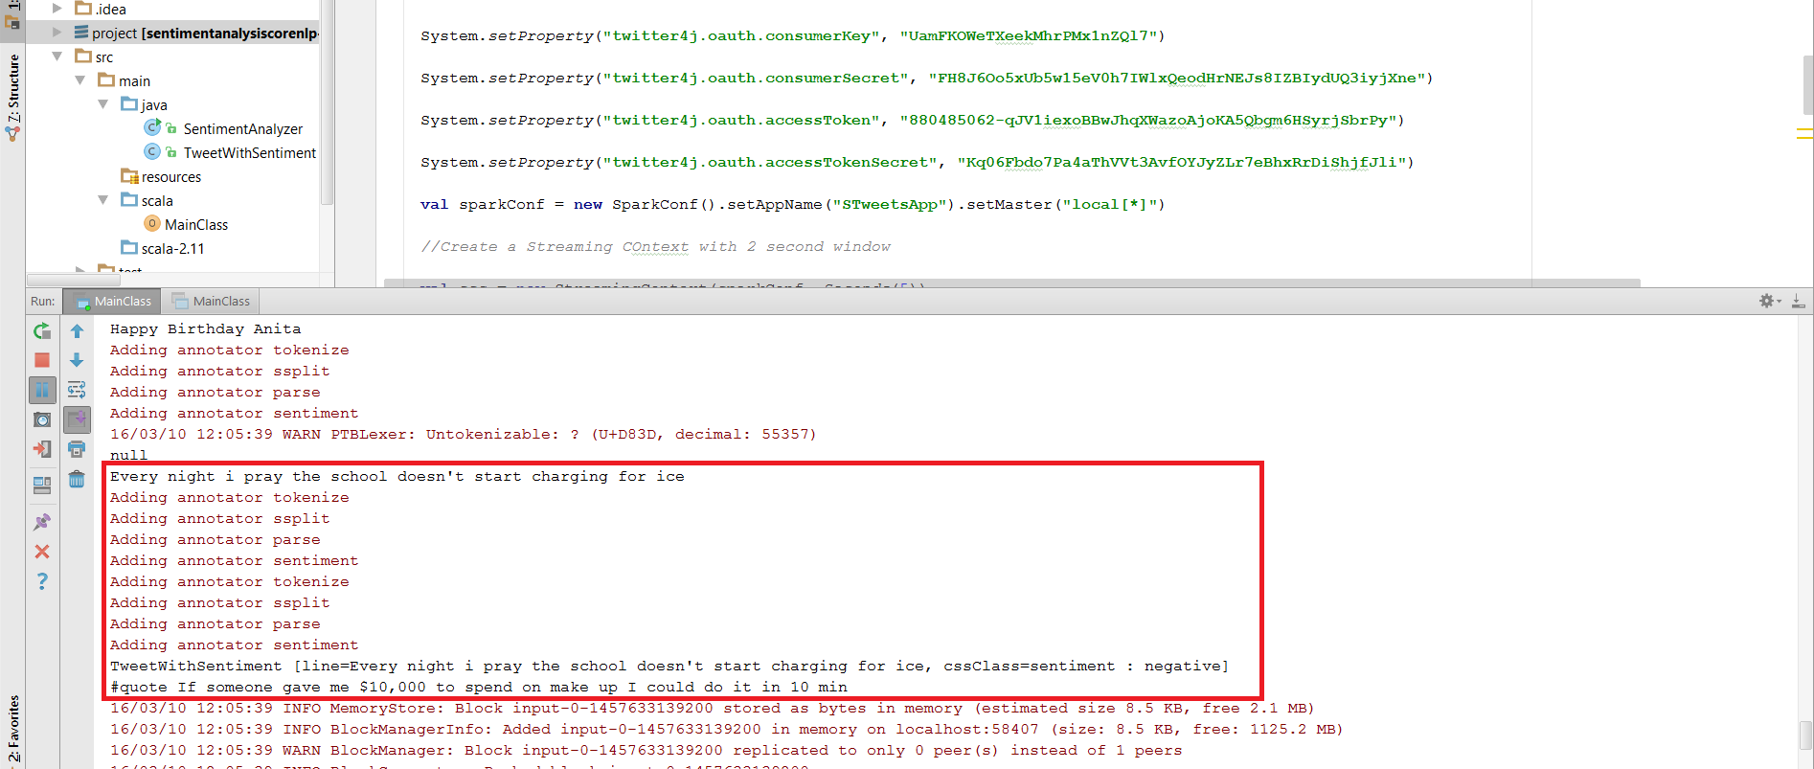

**Question 2: Make recommendations (related to your own project)**

**a. Training Data: the Twitter Streaming/categorized data (The categorization here would be from your previous lab 5&6).**

**b. Testing Dataset e.g., UserId, Category, Rating**

**c. The rating based on sentiment analysis, retweet count would be interesting.**

**d. Expected outcome is to make a recommendation based on user profile (e.g., preferences, location, gender, age)**

**Description**: Here we had trained the system based on the tweets and had recommended certain tweets of other user based on the groups and we have used the collaborative filtering technique for the same. Here the tweets are stored in a file making the data static however we shall try in our next work to make this data dynamic.

**Screenshots:**

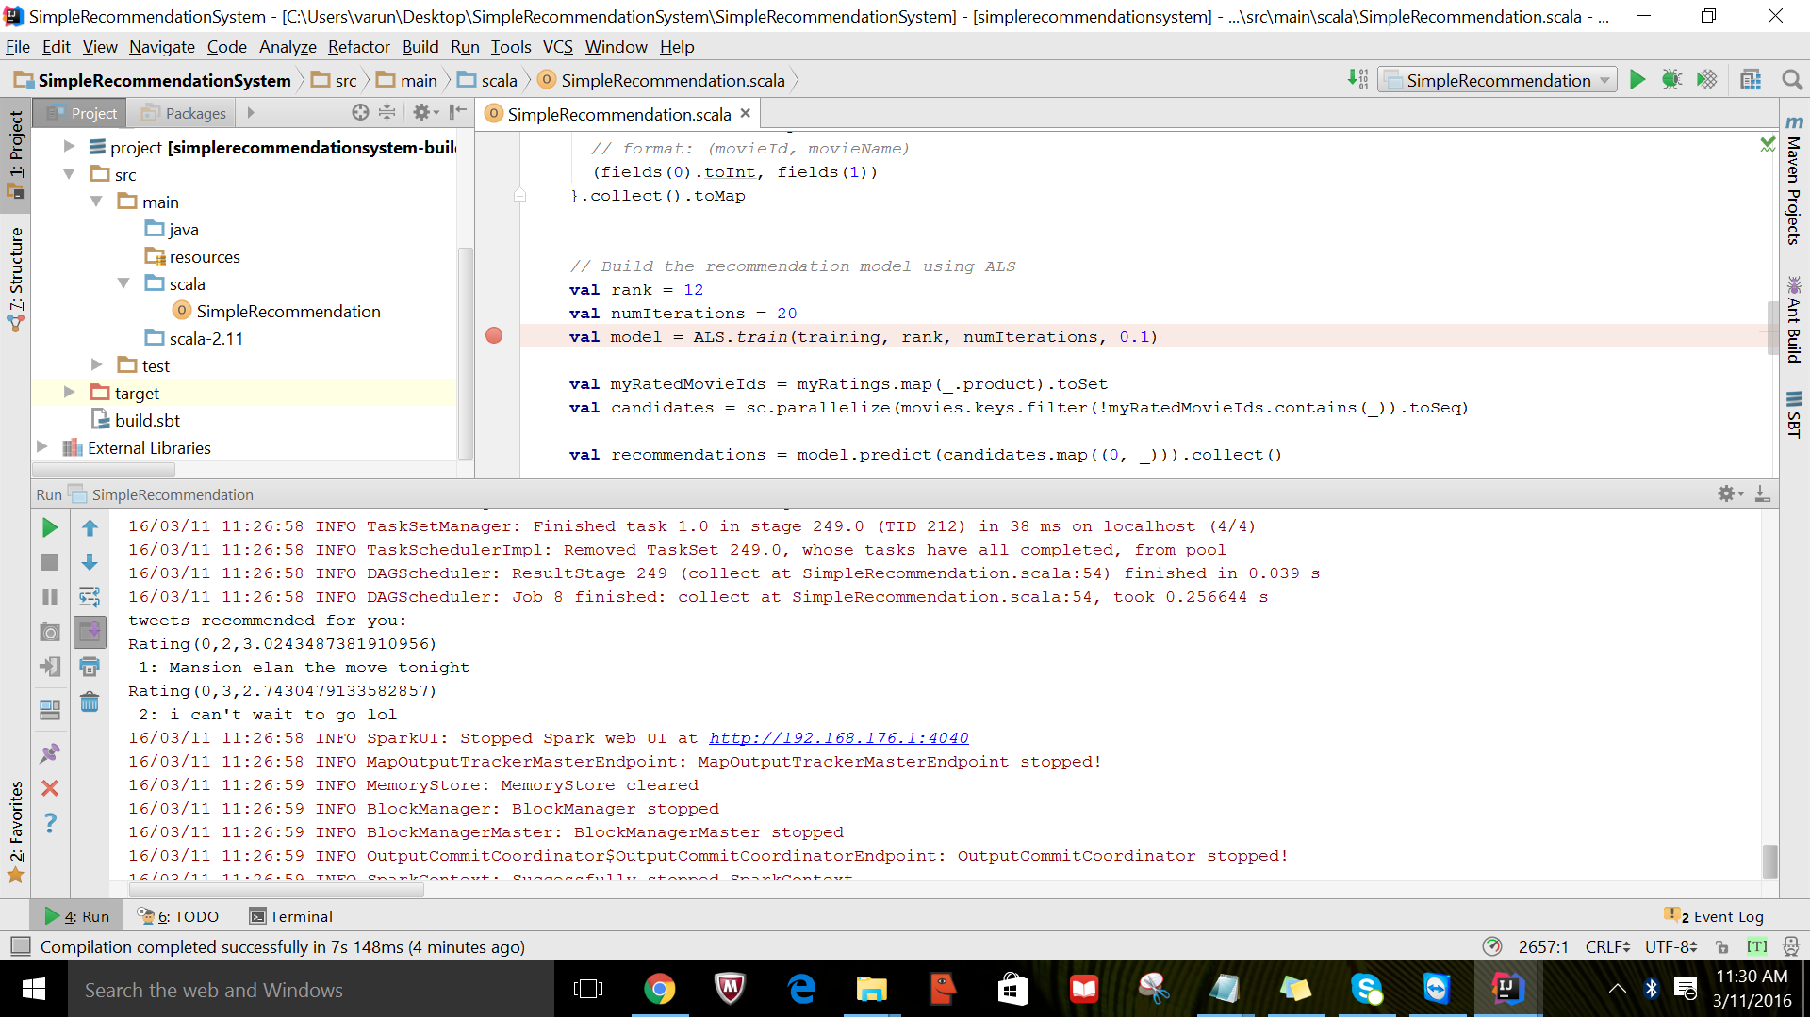

**3) Twitter trend notification to smartphone/smartwatch**

**Description:** After finishing the sentiment analysis, I had send these over to display on the smartwatch using the Socket Client program.

**Screenshots:**

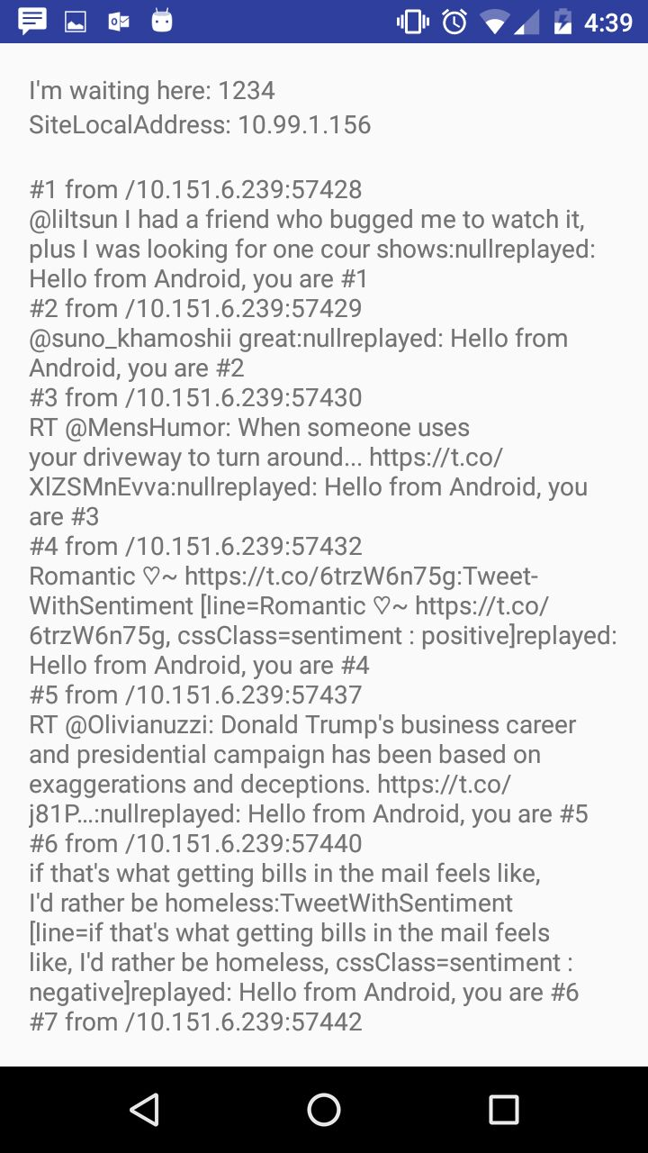

**4) Searching or recommendation through smartphone/smartwatch**

**Description:** Here we had sent out the results to the smart phones using the socket client connections.

**Screenshots:**

